**Year 12 Essential Mathematics**

**Investigation 2 – Building Ramps Time allowed: 30 minutes**

**Validation Test**

Part 1:

1. Consider the following ramp:

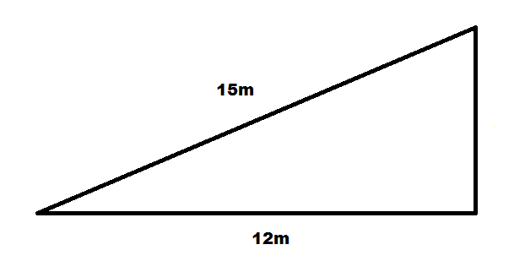

a) What is the height of the ramp?

15² = 225

12² = 144

Height = 9m

(3 marks)

b) If the two known pieces became 7.5m and 6m, what would the new height be?

Both pieces are halving, so the new height would be 4.5m

(2 marks)

c) If the two known pieces became 22.5m and 18m, what would the new height be?

Both pieces are increasing by half so the new height would be 13.5m

(2 marks)

d) If the height became 18m, what would the two other lengths become?

The height is doubling so the others would become 30m and 24m

(2 marks)

2. Consider the following ramps:

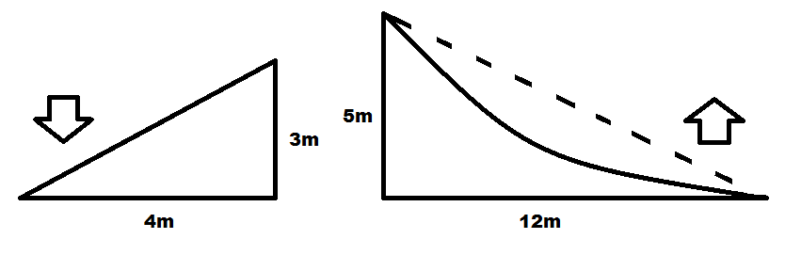

a) What is the total length of the down ramp?

3 + 4 + 5 = 12m

(2 marks)

b) What is the total length of the up ramp?

(the top piece has to be extended by two metres to make the curve)

5 + 12 + (13 + 2) = 32m

(2 marks)

c) What would be the total length of the ramp if both heights and lengths were halved?

Down: 1.5 + 2 + 2.5 = 6m

Up: 2.5 + 6 + (6.5 + 2) = 17m

(4 marks)

d) If all pieces of wood have to be 0.5m wide, what is the total area of wood that is required?

(Use your answers from part a & b)

44 x 0.5 = 22m²

(2 marks)

e) Which of the following is the best amount of wood to buy to build these ramps?

i) 26m²

ii) 24m²

iii) 21m²

(1 mark)

**Part 2**

**3. Answer the following multiple choice questions** (4 Marks – 1 mark each)

### The three sides of a right-angled triangle measure 40 m, 41 m and 9 m. The length of the hypotenuse is:

### (i) 9 m (ii) 40 m (ii) 41 m (iv) none of these

1. A map has a scale of 1 : 5000. 5cm on the map is equal to how far in real life?

### (i) 5000 cm (ii) 2500 cm (iii) 25 m (iv) 250 m

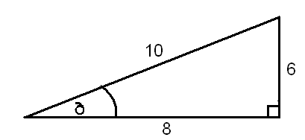c) In relation to the angle, which is the opposite side?

### (i) 10 (ii) 8 (iii) 6 (iv) none of these

1. The value for *x* in the diagram is given by:

12__

sin 30O

12__

tan 30O

### (i) 12 x sin 30O (ii) 12 x cos 30O (iii) (iv)

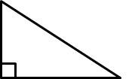

x

12

30˚

**Question 4 (5 marks – 3,2)**

|  |
| --- |
| 1. A boy notices a bird sitting at the very top of a 10m tall tree. If he is standing 8m from the base of the tree, what is the distance between his eye and the top of the tree? |
| 1. What is the angle of elevation from the boy’s eye to the top of the tree? |

$$tan^{-1}(\frac{8.6}{8})$$

$$=47°$$

**Question 5 (3 marks)**

The school council needs to have a ramp build over the steps of each of the building exits, to accommodate a student in a wheelchair. If the school building is 35cm off the ground and the ramp length is 61cm, how far should the steps reach out to accommodate the ramp?

$$b= √({67}^{2}- {35}^{2})$$

$$b=57cm$$

**Question 6 (3 marks)**

A ladder 12 m long leans against a wall. If it forms an angle of 400 with the ground, how far is the bottom of the ladder away from the wall?

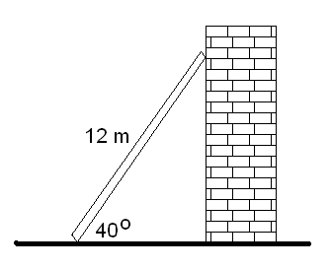

$$\cos{40 ×12=9.2m}$$